DAILY ONLINE ACTIVITIES SUMMARY

|  |  |  |  |  |  |
| --- | --- | --- | --- | --- | --- |
| Date: | 31/05/2020 | | | Name: | Poojashree T |
| Sem & Sec | 8 sem B sec | | | USN: | 4AL16CS064 |
| Online Test Summary | | | | | |
| Subject | | IOT | | | |
| Max. Marks | | 20 | Score | | 17 |
| Certification Course Summary | | | | | |
| Course | R language tutorial | | | | |
| Certificate Provider sololearn Duration 6.00hrs | | | | | |
| Coding Challenges | | | | | |
| Problem Statement: seating arrangement | | | | | |
| Status: Solved | | | | | |
| Uploaded the report in Github | | | Uploaded | | |
| If yes Repository name | | | Poojashree T | | |
| Uploaded the report in slack | | | yes | | |

Online Test Details: (Attach the snapshot and briefly write the report for the same)

Certification Course Details: (Attach the snapshot and briefly write the report for the same)

Coding Challenges Details: (Attach the snapshot and briefly write the report for the same)

Online test

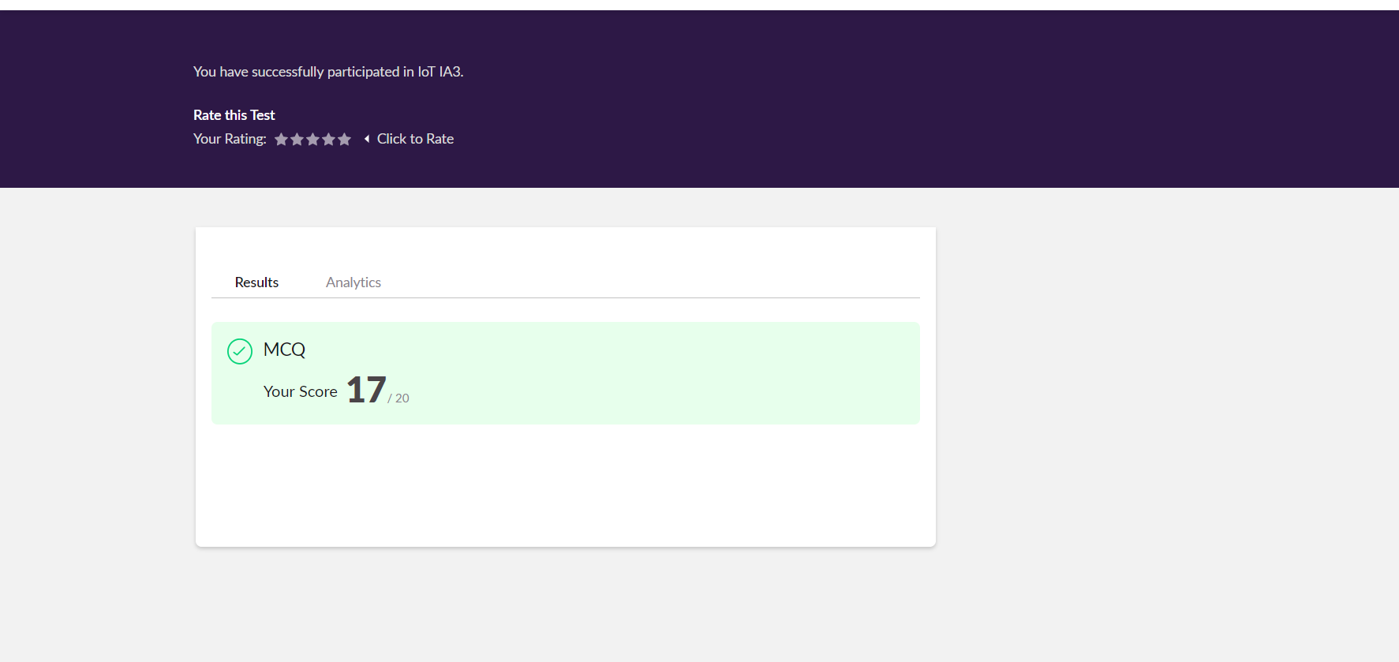

Online certificate course

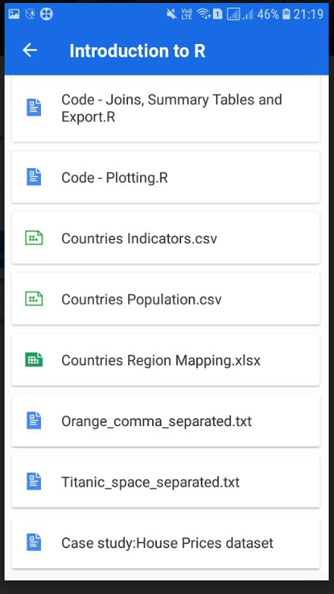

Online coding

